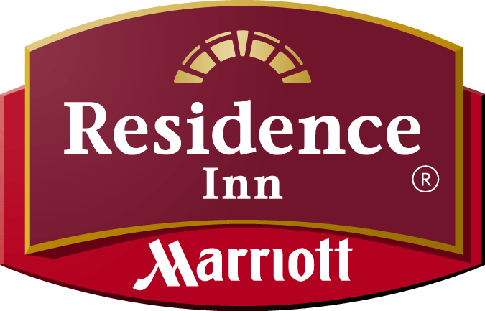
Welcome Company Name Guest!
Add company logo here

We are delighted to have Company Name as a corporate partner. In an effort to better understand Company Name and its business partners, we ask you to take a moment to fill out the questions below.

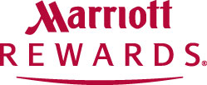We know that being away from home on business travel can be tough. Wouldn’t it be nicer to be away on vacation with your friends or loved ones? The _______Residence Inn will help you “Get There Faster” by giving you 500 bonus points for filling out this survey. Please return it to the front desk so that your bonus points can be processed today!

Guest Name: _________________________________________________

Email Address: ________________________________________________

Are you employed directly by Company Name? ______________________

If yes, where is your home office? Where are you traveling from? _____________________________________________________________

Are you a vendor or consultant working at Company Name? ____________

If yes, what is your company name? _______________________________

Where are you traveling from? ___________________________________

Are there others traveling with you that are not staying at this hotel?_____

Where are they staying? ________________________________________

Who makes the decision on where you and others where your company stay in the area? _______________________________________________
Would you be like to earn additional bonus points by referring colleagues to our hotel? _________________________________________

