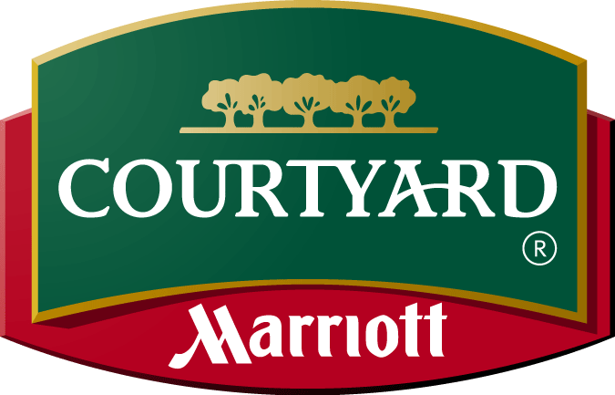

December 11, 2013

Dear Sugar,

We appreciate the opportunity to provide a meeting space for Sugar Baker Int. In showing our commitment to providing the best accommodations and service in Kansas City, we offer:

- Historic hotel located on the beautiful Country Club Plaza
- King or double queen bedded rooms with refrigerator and microwave
- Cable plasma TV’s
- Wireless high speed internet
- In-room coffee, hairdryer, iron and ironing board
- Dual line telephones with voice mail call waiting
- Courtyard Café available for breakfast seven days a week
- Lobby bar and lounge
- Business center and library
- Market available for last minute items
- Fitness center with Nautilus equipment, treadmills and free weights
- Outdoor pool with sundeck, whirlpool
- 3 meeting rooms with up to 980 square feet of meeting space, with High Speed Internet access available

We would like to extend the following group rate for your travelers for the months that you have specified:

April 16-19, 2009  Thurs.-Sun. | King Rooms | 25-30 Rooms | $129.00
*** | *** | *** | ***
April 17, 2009  Friday | Ballroom | 25 ppl | $350.00
April 19, 2009  Sunday | Ballroom | 25 ppl | $350.00

!!!Attached is a banquet menu for your meetings. Please look at our independent website at www.courtyardkansascity.com for a virtual tour of the hotel!! And don’t forget our complimentary parking garage!!

If you have any questions please let me know. These rates are subject to 15.075 % tax and 20% gratuity. Please let me know as soon as you are ready to book and I will forward a contract to your attention. Thank you for your consideration. I look forward to doing business with you in the future. Have a great day!

Sincerely,
Bee Sweet
Sales Assistant
Courtyard by Marriott
1000 Sweetie Lane
Kansas City, MO 64110

